UNITED WAY AND AFL-CIO PARTNERSHIP

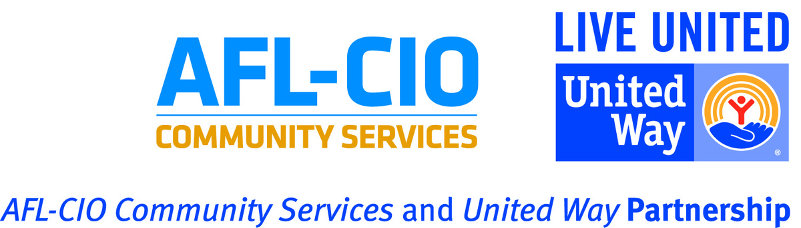

Since 1946, the American Federation of Labor and the Congress of Industrial Organizations (AFL-CIO) and United Way Worldwide have enjoyed a cooperative relationship through which they and state and local United Ways have provided services to members of organized labor, their families and their communities. Our strong partnership between management and labor has a positive and powerful impact on United Way of the Greater Dayton Area. Labor representatives serve in many key leadership roles within United Way. They serve on our board of directors, campaign cabinet, allocation and many committees. When management and labor work together on a common cause, employees are motivated.

The AFL-CIO and United Way work together to:
- Solicit contributions from workers through payroll deduction, which account for about two-thirds of the funds that United Way raises each year.
- Train union members to assist co-workers and their families with information about available local services and to refer them to the appropriate organizations.
- Recruit, train and help place members of organized labor on the decision-making bodies of health and human-service organizations. This is done at the national, state and local levels.
- Provide a staff of more than 160 full-time AFL-CIO Community Services liaisons to serve as links between their state federations and central labor councils and United Way in 165 communities across the United States. In addition, 18 local labor agencies and four state labor agencies receive direct United Way support.
- Coordinate, lift up and promote community service activates of union members in the community.
- Enhance community involvement by providing a variety of community service opportunities throughout the year, such as: UCAN Training, Day of Caring, Workers Memorial, Golf Tournament and United Way’s

The Miami Valley AFL-CIO Central Labor Council has been an official partner of United Way of the Greater Dayton Area for over 40 years. Since 2002, United Way of the Greater Dayton Area has funded the AFL-CIO Labor Food Pantry. The “Labor Food Pantry” opened in 1984, in order to, provide nutritious food and overall support for union members and their families. As of today, the “Labor Food Pantry” serves union members and their families in three states and all citizens who reside in the 45414 zip code.

